 | Solar Charger Kit  Instructions
Date: | 15/09/17 | Version: | 1.0 | By: | Matt Little

This is a DIY solar LiIon charger unit.
It is designed to run small electronics projects (such as data-loggers and environmental monitoring units) in places where there is no supply of electricity. I designed it originally to run a small weather station which monitored and wirelessly sent back data to a base station.
It uses the Texas Instruments BQ24210.
This is a 800mA single-input, single cell Lithium Ion battery charger IC. The datasheet is available here:http://www.ti.com/lit/ds/slusa76b/slusa76b.pdf
This IC is pre-soldered, as it is a very small SMD. All the other parts are through-hole and can be soldered by hand.
The kit uses 2 x 1W 5V solar PV cells (connected in parallel).
This IC is used to recharge a single 18650 LiIon cell, which are widely available in a range of capacities.
The output can be used directly, as the voltage of the LiIon cell (around 3.7-4.4V DC). This can be used on micro-controller projects, such as data-loggers and weather stations which might need a local source of reliable, off-grid power.
There is also a DC/DC converter unit to provide a 5V output. The 5V output is switched. The 5V output can be used to power USB devices or your microcontroller projects.
This is a reasonably simple kit which requires some soldering.
It should take 1-2 hours to build.
Not suitable for under 12 years old.

Parts included:
 |  |  | Laser-cut Enclosure |  |  | 3 x AA rechargeable batteries
1W Solar PV Modules
1W Solar PV Modules |  |  |  |  |  |  |  | Battery Holder
DC-DC
Converter

DC-DC  Converter |  |  |  |  |  |  |  | 7 x M3 Hex spacers
PCB |  |  |  |  |  |  |  | 7 x M3 6mm  7 x M3 8mm
 |  |  |  |  |  |  |  | Sticky Pads
Wire
 |  | Diode 1N4001 |  |  |  | Switch + 2 x M2.5 screws

Enclosure Parts:
Top 1 |  | Front
Top 2
Top 3 |  | Back
Bottom 1
Bottom 1
Bottom 1 |  | Switch  Holder

PCB Parts List:
Ref | Item | Quantity | Ref | Item | Quantity
BT1 | 18650 Cell Holder | 1 | R1 | 1k resistor | 1
Battery | 18650 Cell | *Not included | R2 | 100k Resistor | 1
C1, C2 | 1uF Capacitor | 2 | R3, R4 | 2k2 Resistor | 2
D2, D3 | LED | 2 | PV1, PV2 | 1W 5V PV module | 2
DCDC | DC-DC boost converter | 1 | SW1 | Switch | 1
P1, P2, P3, P4, P5, P6 | 2 way Screw Terminal | 6 | U1 | BQ24210 | 1
PCB1 | Circuit Board | 1

*Note: We do NOT supply the 18650 size Lithium Ion cell. This is due to shipping restrictions. These cells are easily available locally.

Hardware Parts List:
Ref | Item | Quantity | Ref | Item | Quantity

Tools required:
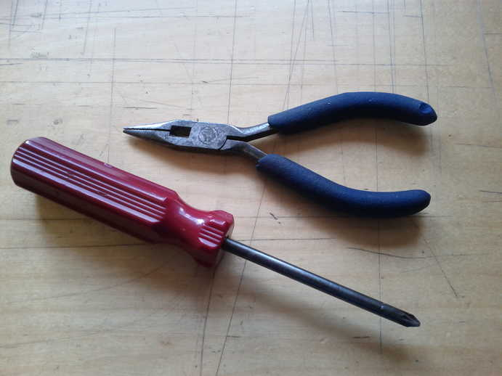
Posi-drive
Screwdriver
Long-nosed
Pliers
Soldering Iron
Solder
Side cutters
(not shown)

Instructions:
Step: 1

Step: 2

Step: 3

Step: 4

Step: 16 | Build is finished!
Have a nice cup of tea.


Note: The weather and available sunlight is variable, so there are no definite rules about recharging times.
If outside on an average UK summers day the batteries will be fully charged in one day.
If outside on an average UK winters day then the batteries will be fully charged in 2-3 days.
If used behind a window, the glass will affect the available sunlight and increase the recharge times by a factor or around 50%.

Contact details:
This kit has been designed and produced by:
The Curious Electric Company
hello@curiouselectric.co.uk
www.curiouselectric.co.uk
Hopkinson Gallery, 21 Station Street, Nottingham, NG2 3AJ

We would like you to be happy with this kit. If you are not happy for any reason then please contact us and we will help to sort it out.

Please email hello@curiouselectric.co.uk with any questions or comments.
Please tweet us at @curiouselectric

If any parts are missing from your kit then please email hello@curiouselectric.co.uk with details, including where the kit was purchased.

More technical information can be found via www.curiouselectric.co.uk

Circuit Schematic:

Useful Notes:

